Instructions for Construction

The following table lists all materials one will need to build the Dome.

**Fabricating the Electronics**

The following materials are required to build the electronics:

Table F2: Materials Required for Construction of Electronics

|  |  |  |
| --- | --- | --- |
| **Material** | **Specifications** | **Quantity** |
| Push Buttons | 0.25’’ in diameter | 4 |
| Resistor | 2200 Ω | 4 |
| Arduino | Arduino Uno Board | 1 |
| LED Light | Color-Changing RGB | 4 |
| LED Screen | I2C | 1 |
| Microphone | SparkFun Product #BOB-09964 | 1 |

The following tools and materials will also be necessary for construction:

* Soldering Iron
* Wiring
* Written Arduino Code

1. Using the 4 push buttons and 2200 Ω resistors, construct four copies of the circuit shown below (see Figure F9).

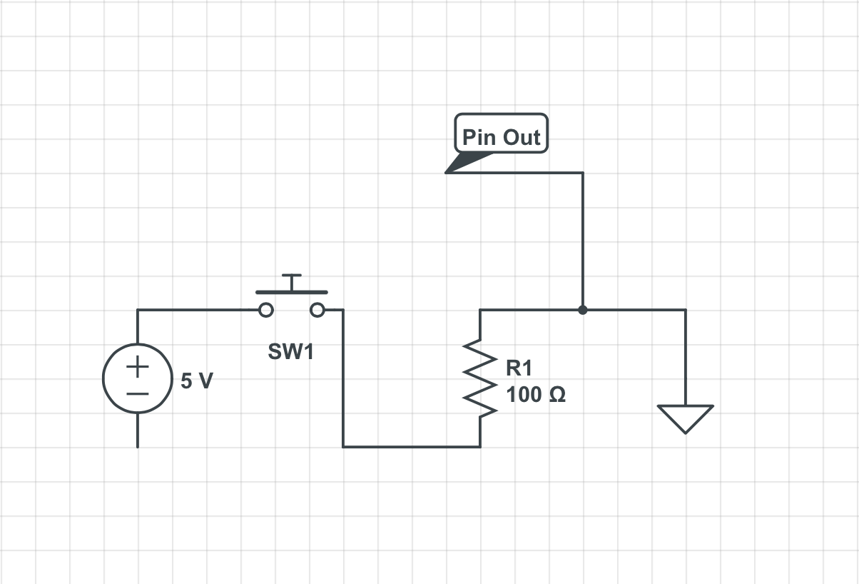

Figure F9: Button and Resistor Circuit

1. Solder the color-changing LED lights together on a circuit board and connect them to the Arduino Uno board. (see Figure F10)

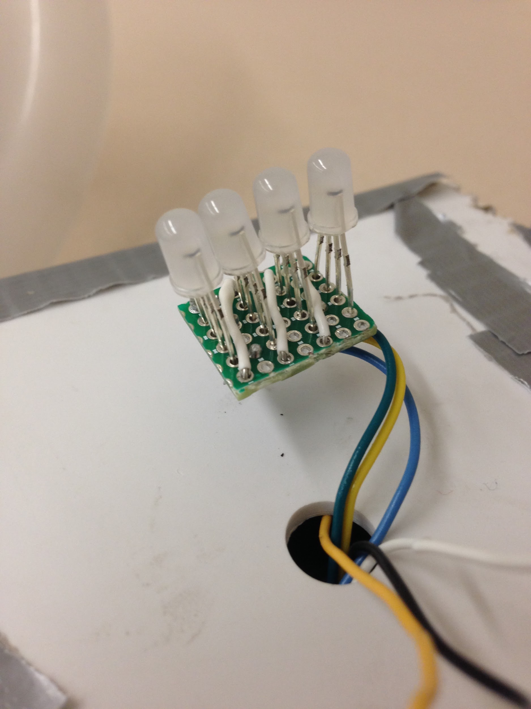

Figure F10: Color-changing LED assembly

1. Connect the I2C LED screen to the Arduino Uno board.
2. Connect the Microphone to the Arduino Uno serial input.
3. Upload the given code to the Arduino through the attached USB cord.
4. Connect the Arduino to a wall socket to power the device.

**Fabricating the Outer Shell**

Table F1: Materials Required for Construction of Shell

|  |  |  |
| --- | --- | --- |
| **Material** | **Specifications** | **Quantity** |
| Polycarbonate | .125’’x24’’x24’’ | 1 |
| Polystyrene | .125’’x18’’x36’’ | 2 |
| Screws | .125’’x1.5’’ | 4 |
| Nuts | Fit to screws | 4 |

The following tools and equipment are required to construct the dome:

* Heat Vacuum Former
* Bandsaw
* Drillpress
* File (diameter approx. 0.25’’)
* Sander
* Phillips head screwdriver
* Soldering kit
* Metal bowl (10.5’’ in diameter)

1. Using the bandsaw, cut the polycarbonate piece to 19’’x21’’ so that it will fit the vacuum former.
2. Using the metal bowl as a form, vacuum form the polycarbonate to the bowl. It should look similar to Figure F1.

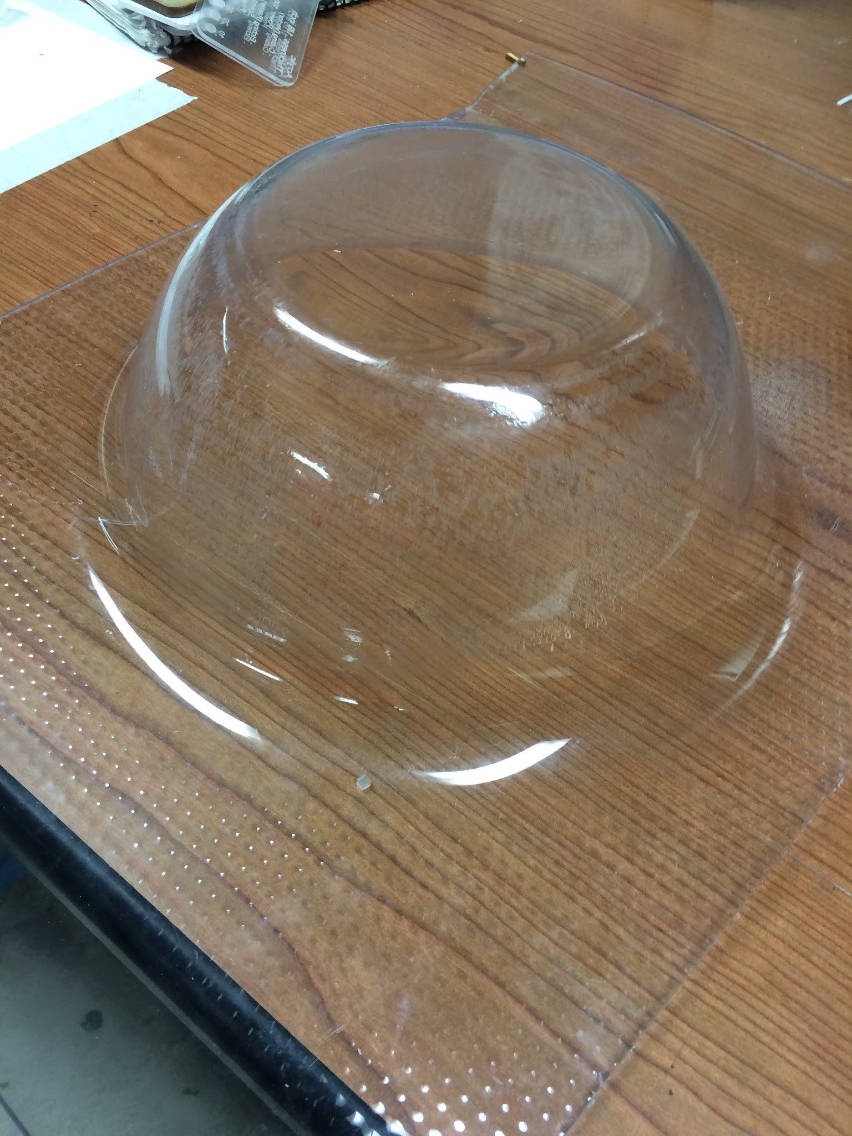

Figure F1: Vacuum-formed polycarbonate

1. Use the sandblaster to frost the plastic until one cannot see distinct figures through it (see Figure F2).

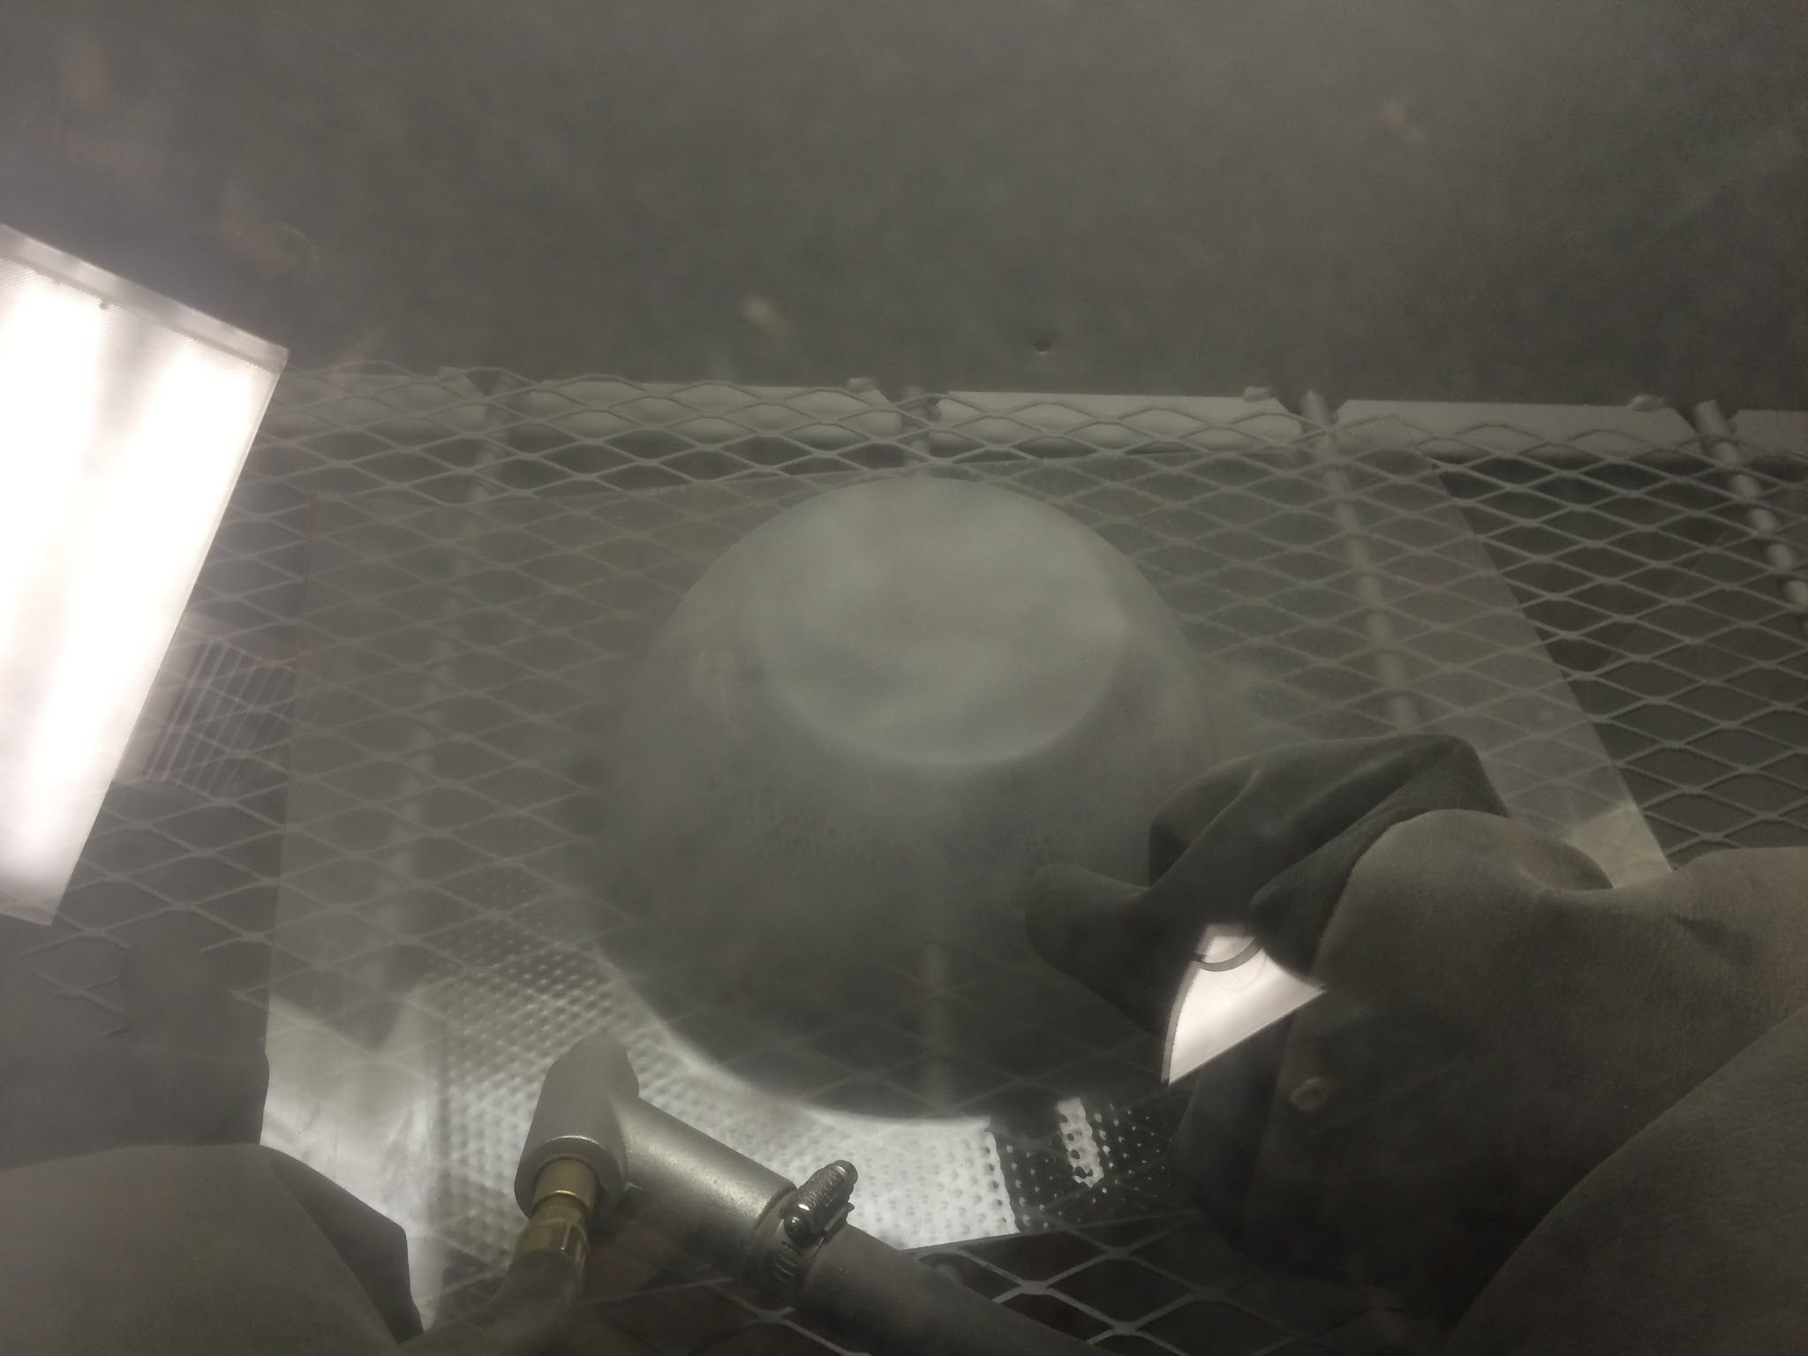

Figure F2: Sandblasting the polycarbonate

1. Using the bandsaw, cut the vacuum formed piece as close to the edge as possible, and set aside this piece.
2. Laser cut the polystyrene according to Figure F3:

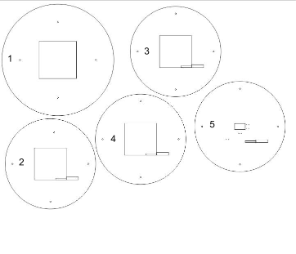

Figure F3: Base plate outlines

1. Throw out all extra pieces from laser cutting EXCEPT for the center square of piece 1.
2. Stack plates 1-5 in numerical order, maintaining alignment.
3. Attach 2 washers to each screw and put screws through each of the four screw holes. The heads of the screws should rest on plate 1 (see Figure F4), and the shaft of the screw should come out of plate 5.

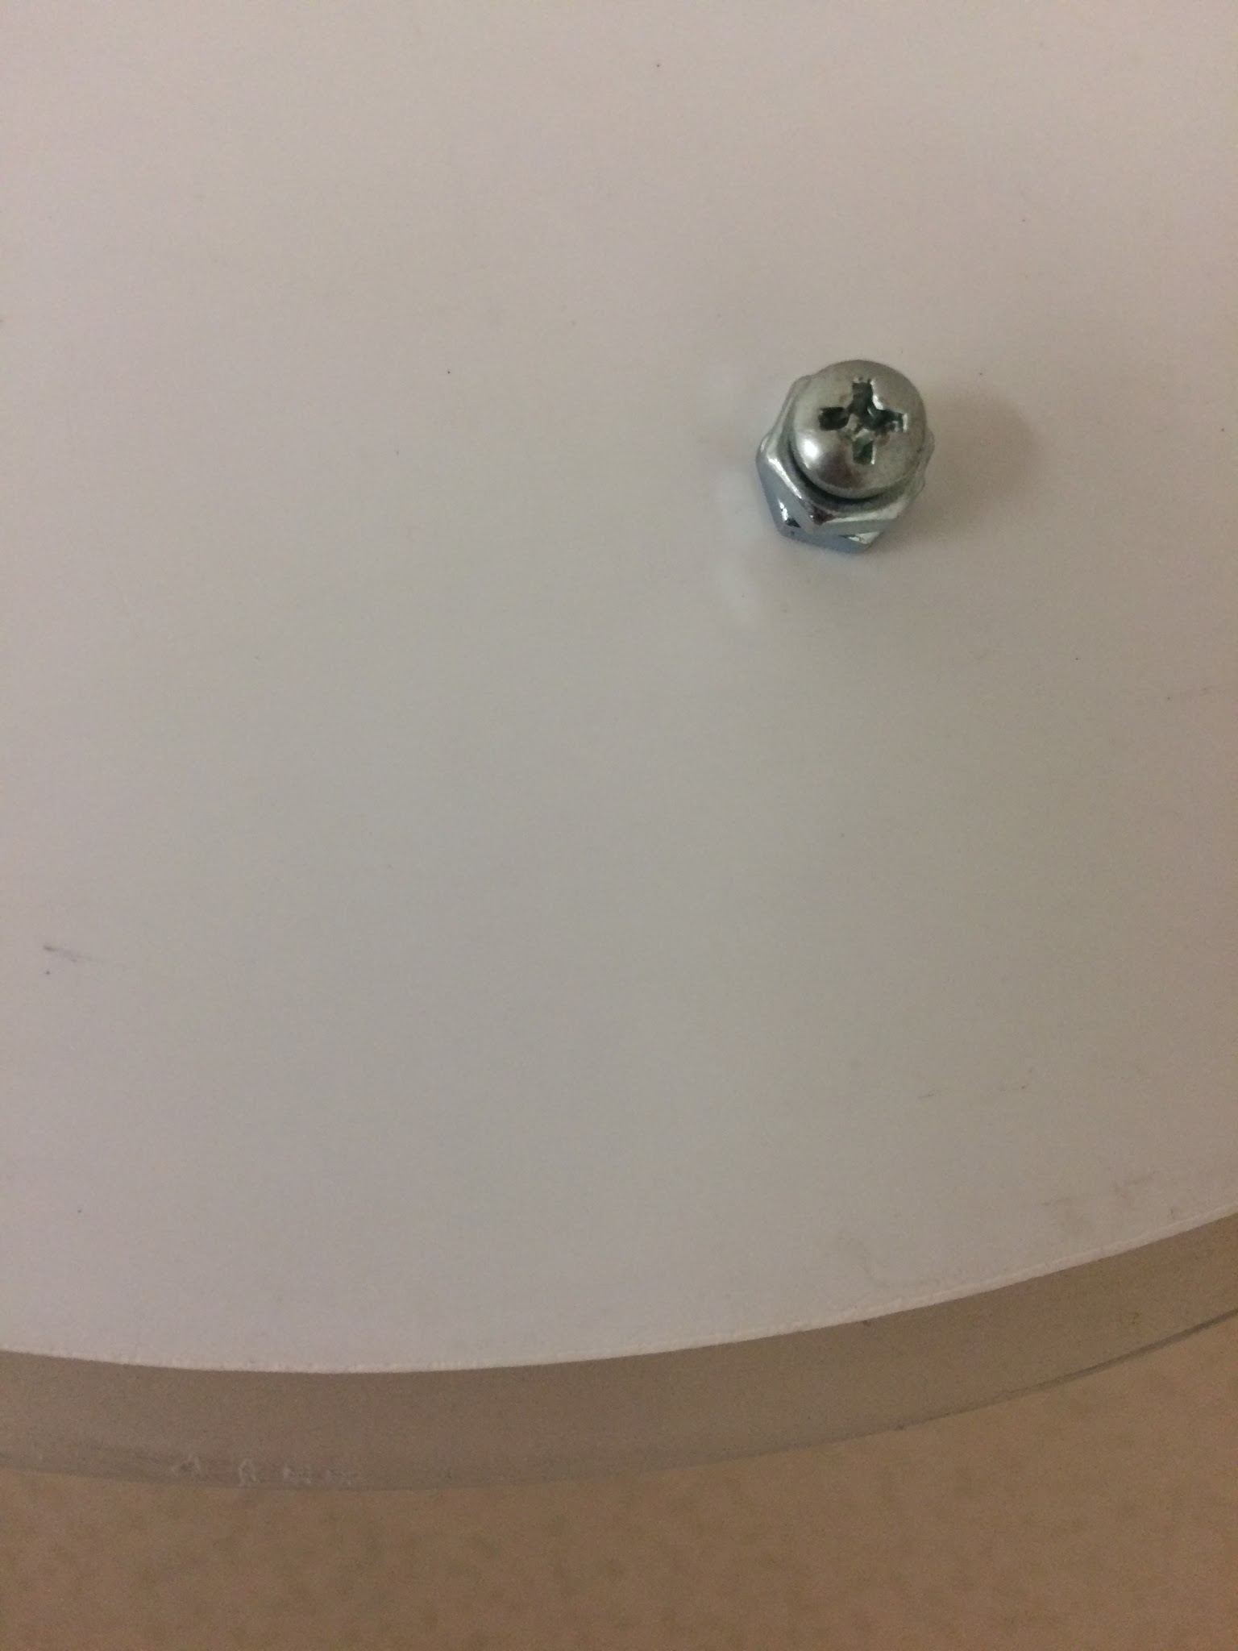

Figure F4: Screw resting on plate 1

1. Attach another nut to each screw, tightening as necessary, to hold together the base plate assembly .
2. Drop the polystyrene assembly into the bottom of the vacuum formed polycarbonate, with plate 1 facing outward. Some of the polycarbonate will overhang the polystyrene (see Figure F5).

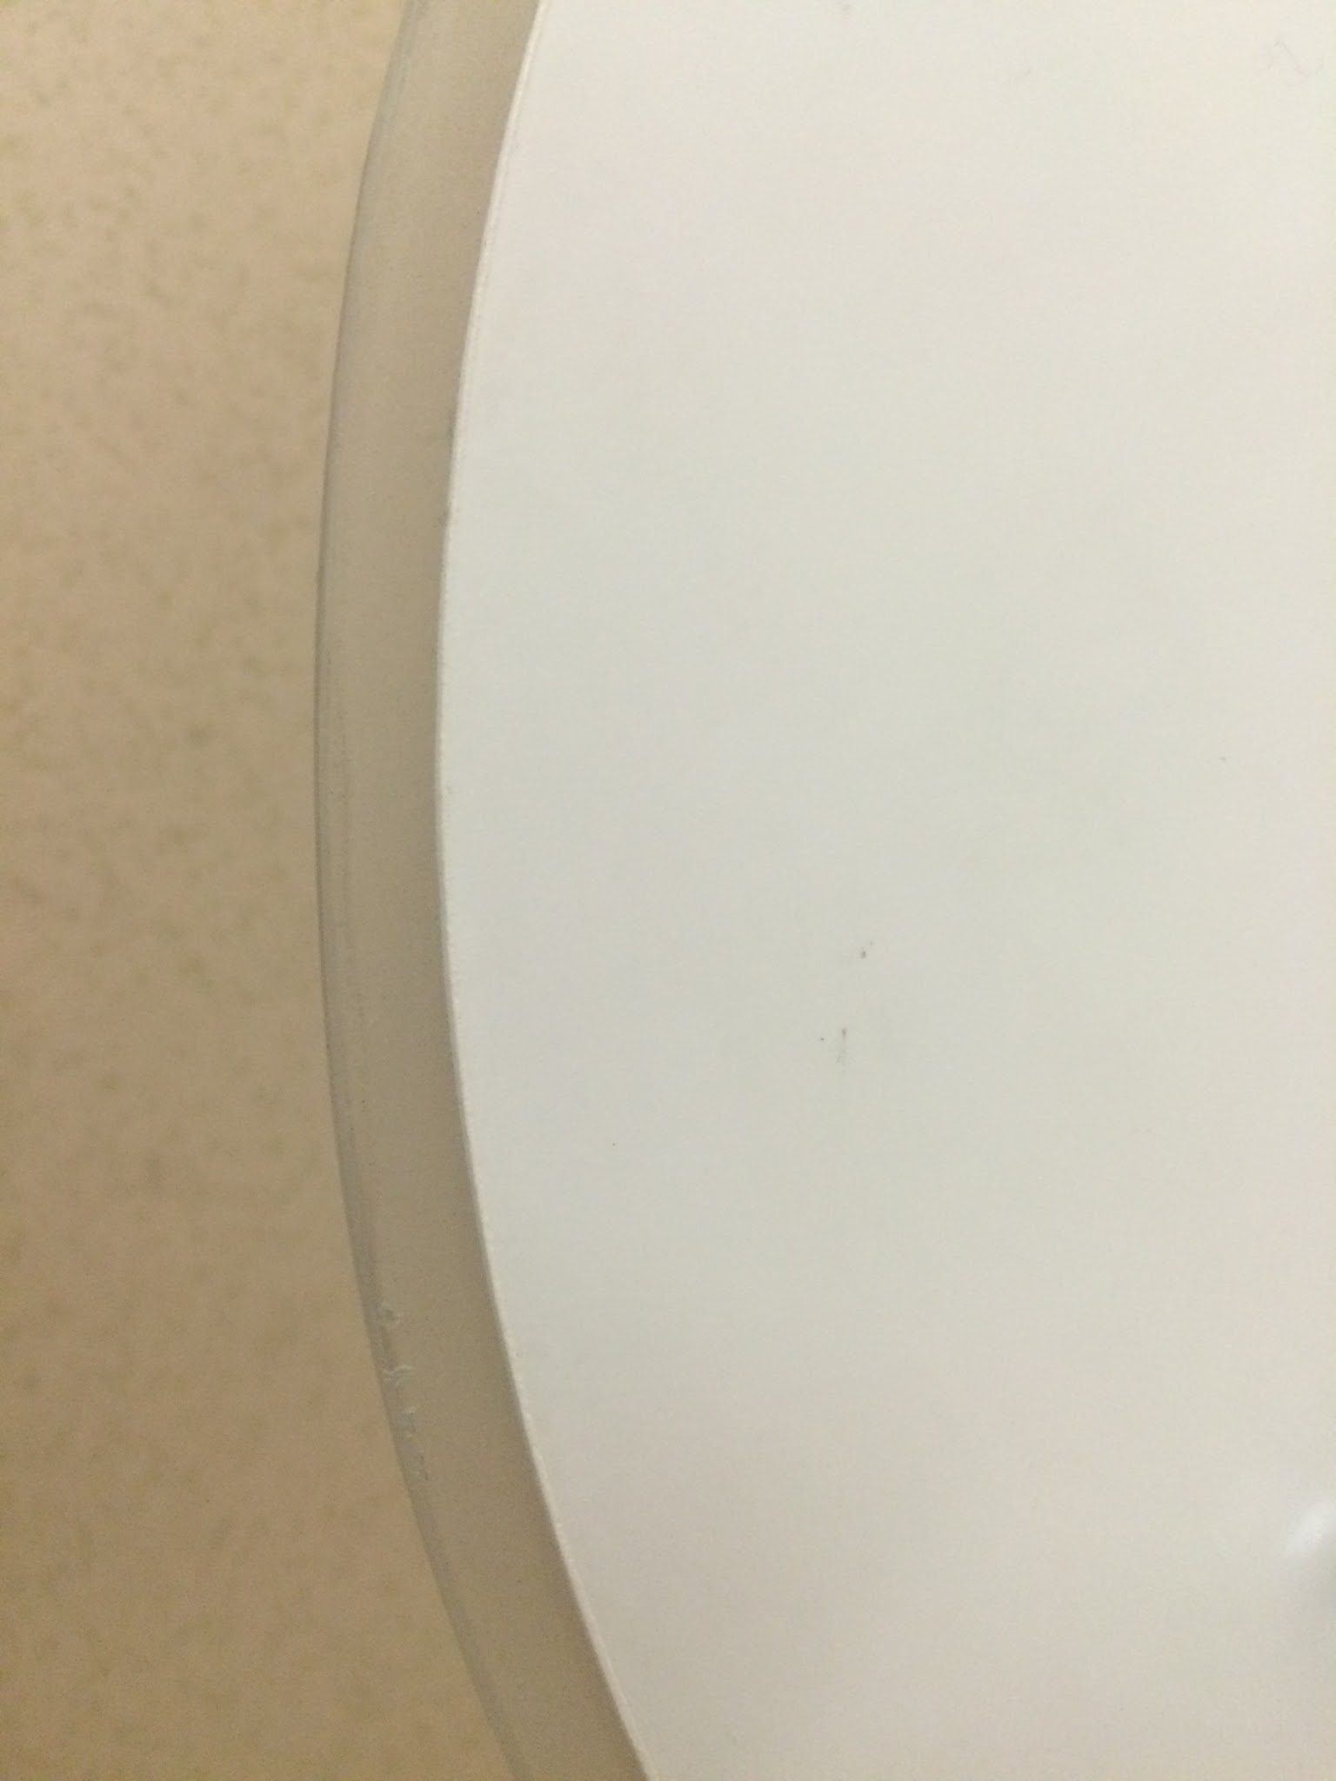

Figure F5: Polycarbonate shell overhanging polystyrene base plate

1. Trace around the polystyrene assembly with a pencil.
2. Sand the polycarbonate shell down to match the polystyrene assembly.
3. Find the center of the top of the vacuum formed polycarbonate, and use a drill press to drill a 0.4’’ hole.
4. Set the polycarbonate shell on its top. Using the small file, file a single spot horizontally to create a 0.25’’ deep U-shaped cutout along the bottom of the shell (see Figure F6).

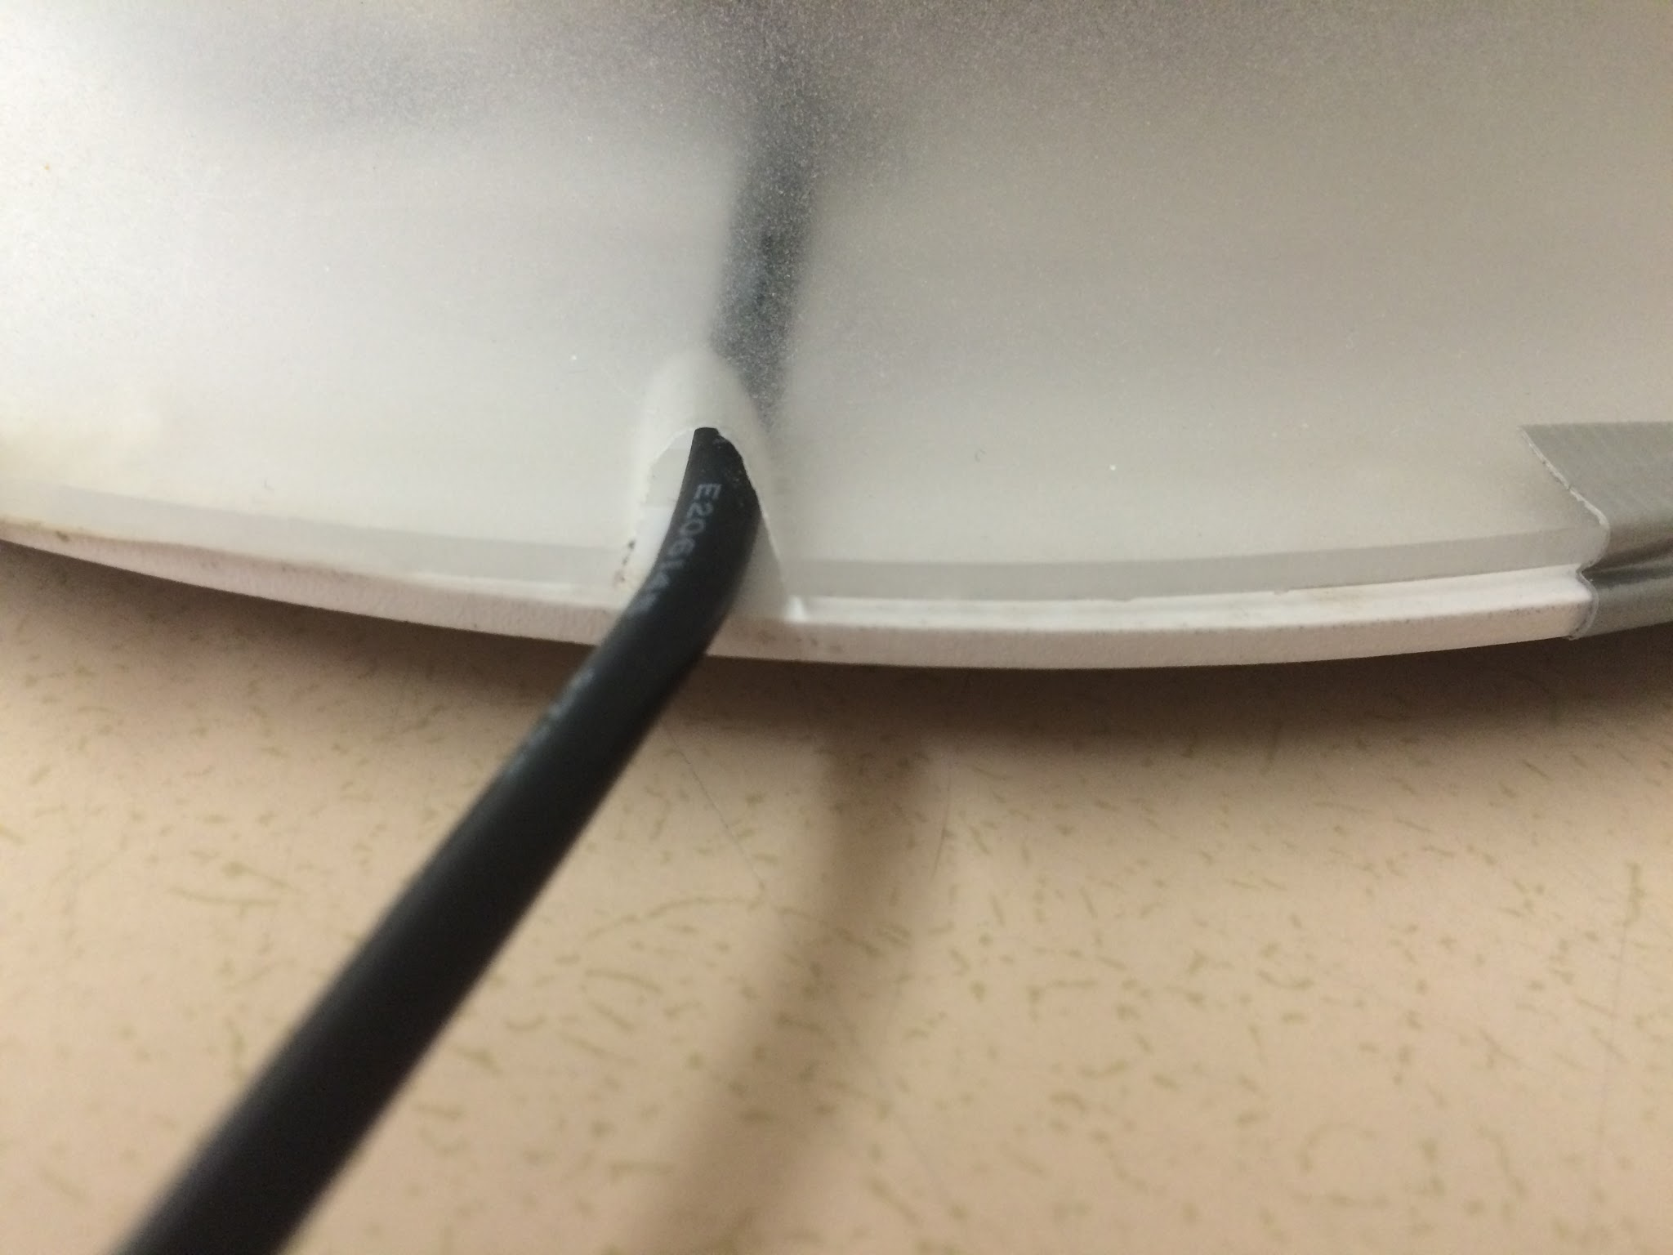

Figure F6: Shell cutout with power cord passing through

1. Laser cut the second sheet of polystyrene according to Figure F7:

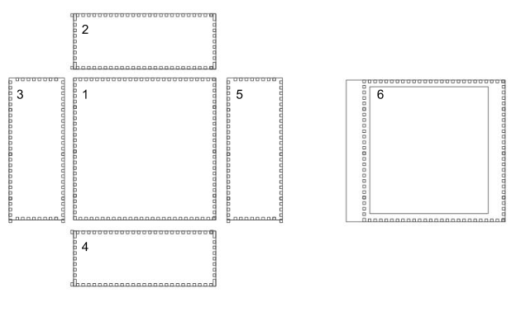

Figure F7: Box plate outlines

1. Drill a hole approximately .5’’ in diameter in the center of piece 1.
2. Place the cut pieces together, with pieces 2, 3, 4, and 5 forming the sides of a box, 1 forming the top, and 6 serving as the bottom.
3. Glue the pieces together (see Figure F8).

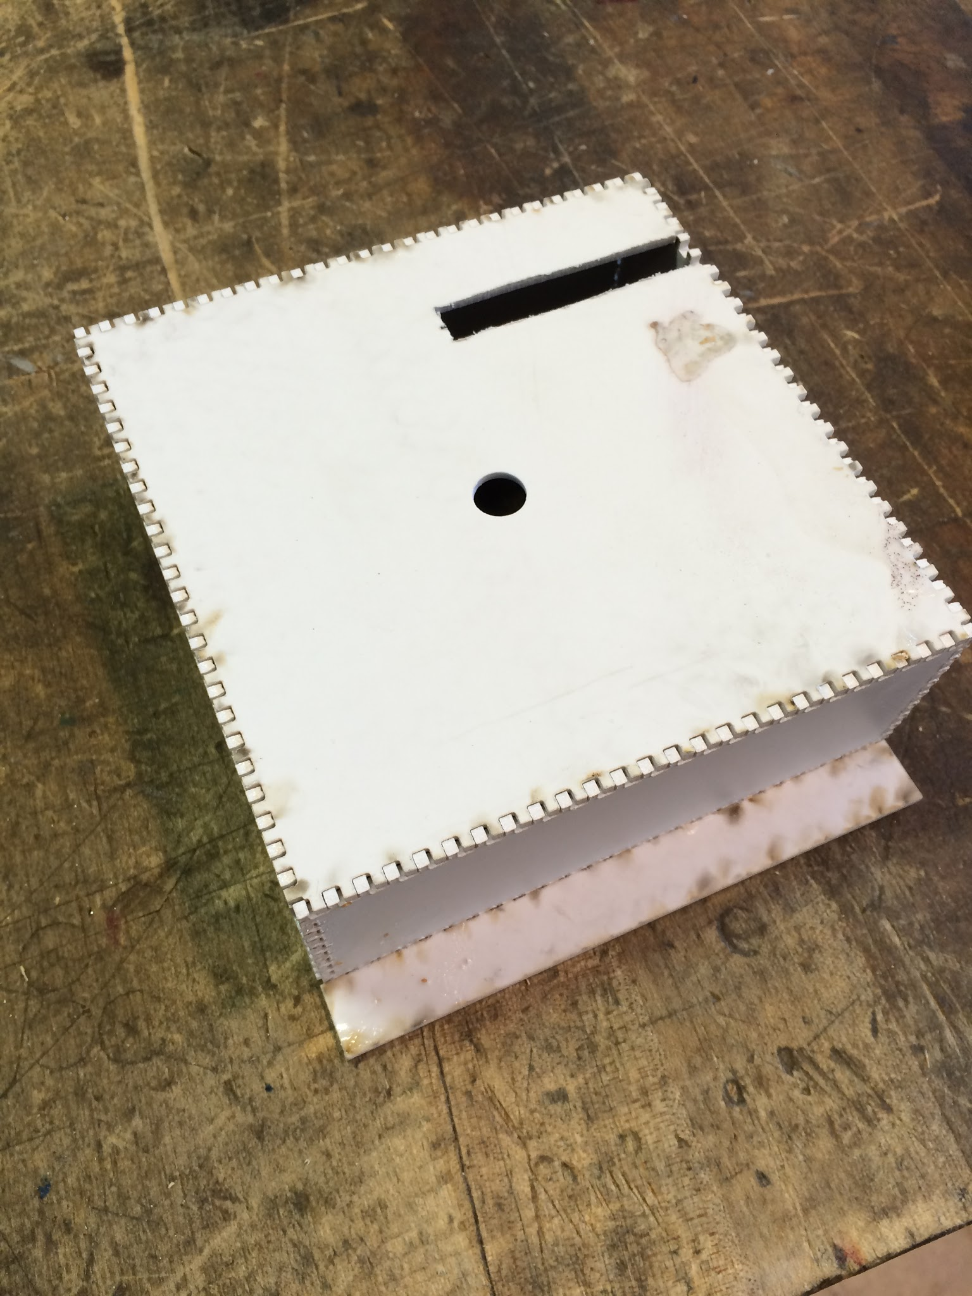

Figure F8: Electronics cover box

1. Insert the electronic assembly into the box (instructions for construction of this assembly are detailed below) and carefully thread the wires through the hole in the top.
2. Secure the buttons and LED screen to the base plate.
3. Glue the box to the interior of the base plate.
4. Place the base plate assembly along the opening of the shell, with plate 1 facing outward
5. Secure the base plate assembly to the polycarbonate shell using glue.